HB Machine Manual(Simple)

Version:V17.04.05.0003

# About Machine

AC220V power supply, the voltage range is AC200V-240V, 220V suggestion, do not exceed 240V,it will cause permanent damage to the machine.

This manual is based on the front of the device, that is, the direction of the person facing the display as the benchmark direction, please use this direction as the reference.

The device has two displays, the top display is for the Keyence CCD display, and the following display is for the dmachine.

# Safety

### Emergency Stop The machine has the emergency-stop buttons on the body that allows the operator to stop the machine from running immediately. At any time you can stop the running by pressing the [Emergency] button. Once the emergency stop button is pressed, the power supply such as the robot, motor, and... will be cut off.

### Safe Guard

When the machine is in normal production, the doors are all closed and the machine will be pause once the door is opened. The software has a [UnUseGuard] switch,if choose the [unuseguard],when the door is opened, the machine will work normally , unless necessary,please close the door for running.

# Operate

## Software

Display as fllowing

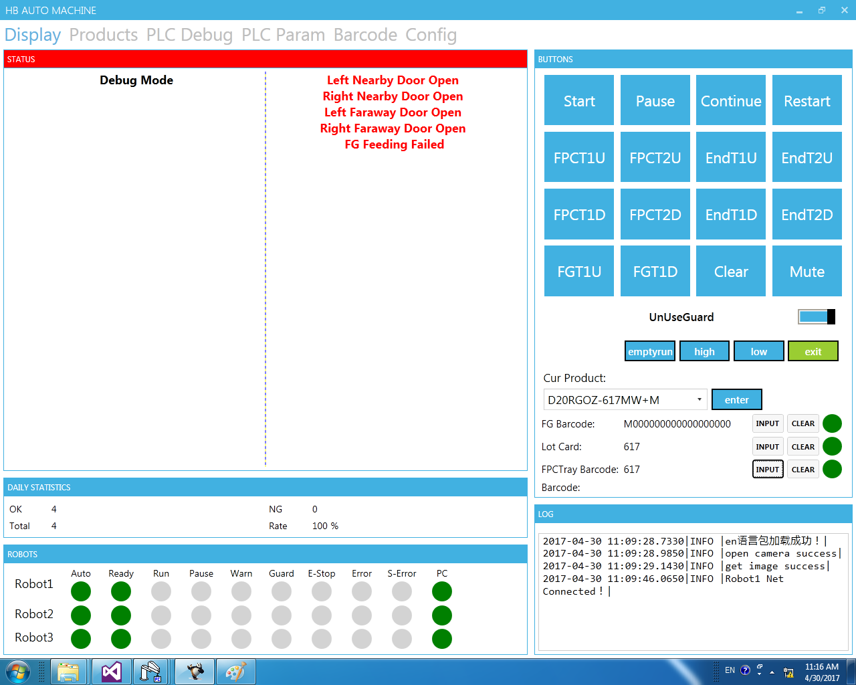

Product Select

Scan Barcodes

Buttons

Robot Status

Production Infomation

Alarm Messages

Machine Status

Before start,we need to scan the barcode of F&G,the lotcard,the FPC Tray barcode,to make sure the product is correct.Click [input] button to begin.

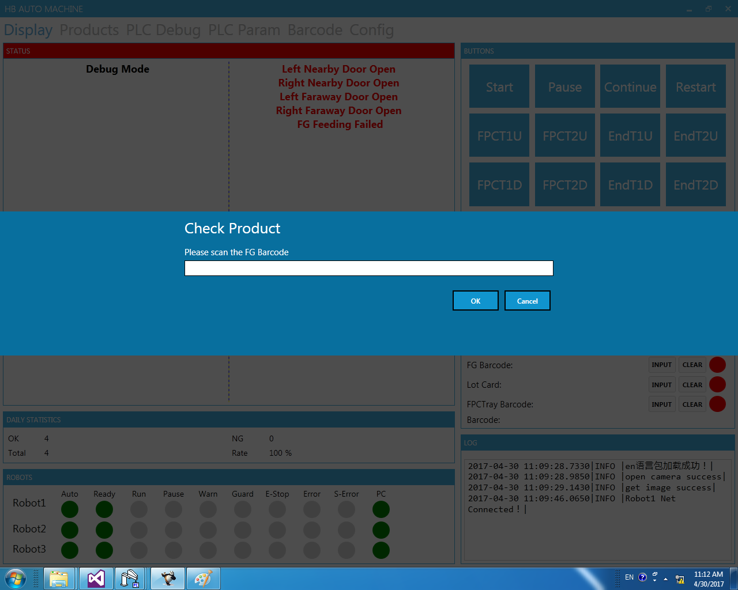

When finished input the barcode and maching success,the indicator will change from red to green.

Change Product

Select the product number, click 【enter】 button, pop-up password box, enter the password [fujikura], then please pay attention to Keyence CCD program is a successful switch!

Note: After the product has been switched, the entered barcode will be cleared.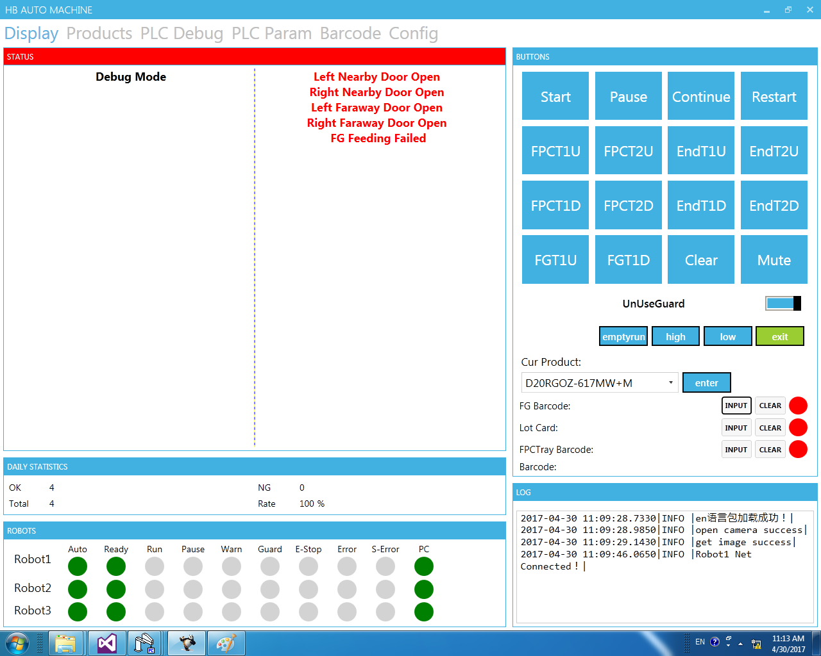

Product Change

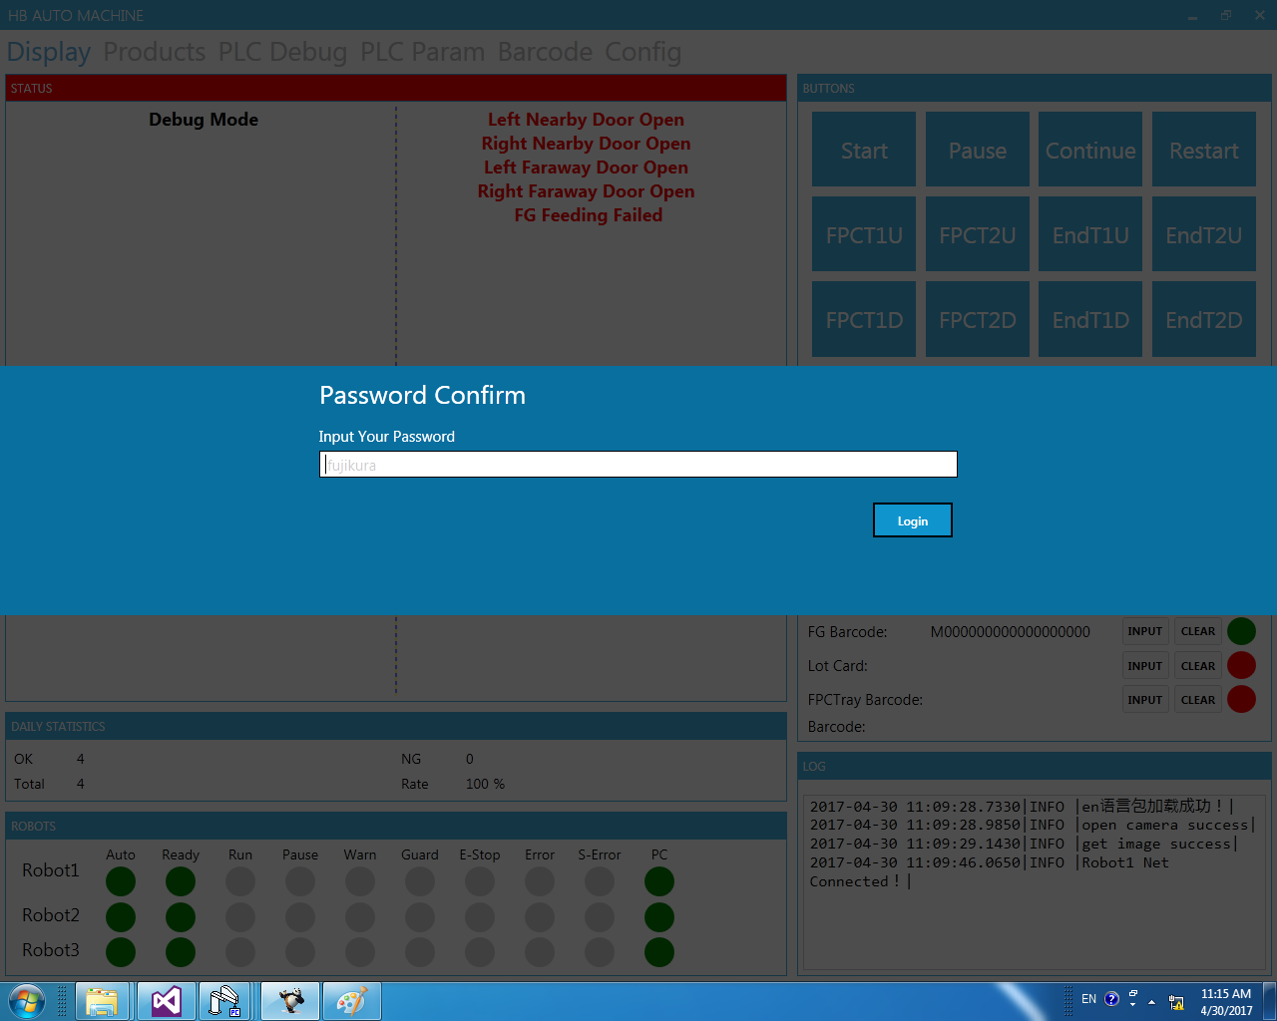

## Prepare for running

1. Robot Status is OK.

2. Press the [reset] button on the machine,then press the [start] button on the machine to initialize the PLC.

3. Click the 【restart】button on software，click【start】button，the robot will homeing.

After homing over,the robot will pause itself,click [continue] to start.

5. Press the [start] button on the machine to start.

Please pay attention to safety at anytime!

Thank you!